**ABSTRACT**

Low-resolution and low-quality images pose significant difficulties in visual object recognition problems essential to surveillance and navigation in a variety of military and civilian use cases. The signal to noise ratio (SNR) and mean square error (MSE) metrics of the super-resolved image have improved significantly because of recent advancements in deep learning-based techniques like EDSR and VDSR. Even though these methods are great at improving individual pixels in images, there is a catch. Just because the pixels are better does not mean the computer can automatically recognize objects or key points in the images. There is more to understanding pictures than just focusing on individual pixels. There may not be a direct correlation between these pixel domain signal quality metrics and machine vision tasks like object recognition and key point detection. A super-resolution technique that improves gradient images and associated features from low-resolution images for the benefit of high-level machine vision tasks is the focus of this work. With scale space adaptive network depth, a residual learning deep neural network-based gradient image super-resolution solution is developed here. After running simulations, we found that this new technique not only improved the accuracy of recognizing key points but also enhanced the quality of the changes in colour or brightness in the images.

***Keywords****: super-resolution, image denoising, image restoration, object recognition*

**CHAPTER-1**

**INTRODUCTION**

**CHAPTER-1**

**INTRODUCTION**

* 1. **MOTIVATION**

One of the huge difficulties in image identification is dealing with low quality images. Particularly in military and surveillance applications, low-quality input photos are used for recognition. But, at longer ranges, the quality of the image becomes unrecognizably poor, which raises serious concerns in some industries, such as defense, where it might be extremely important to have sharper images when attempting to identify and detect drones or other dangers from a distance. Image super-resolution is one of the often-used methods in this situation. Finding a mapping from the low-resolution (LR) image to its high-resolution (HR) equivalent is known as super-resolution. When it comes to single image super resolution (SISR), more pixels are used in a single image to improve both its visual appeal and its recognition efficiency.

* 1. **PROBLEM DEFINITION**

In this project a framework is proposed to create high resolution images from low resolution input images. Images of Hhigh resolution serve as indispensable assets across numerous applications, owing to their superior clarity, detail, and visual fidelity. In industries such as printing and publishing, HR images ensure the production of high-quality materials in magazines, books, posters, and advertisements. The primary objective is to provide a framework for deep learning that can generate visually appealing and semantically meaningful HR images from LR inputs and to preserve all the features and key points of low-resolution images.

We build our model using Super-Resolution Generative Adversarial Network and to evaluate the effectiveness of the model, the SIFT (Scale-Invariant Feature Transform) algorithm is employed to compare key points extracted from both the LR images and the HR images produced by the model. Such an application is valuable across various domains where enhancing image resolution is crucial, including medical imaging, satellite imagery analysis, surveillance systems, and digital forensics, as it enables clearer visualization and more accurate analysis of details in images, ultimately improving decision-making processes and enhancing the overall quality of image-based tasks.

* 1. **OBJECTIVE OF THE PROJECT**

The primary goal of the endeavor is to develop and evaluate a robust image super-resolution system based on the SRGAN model, capable of significantly enhancing the resolution and quality of low-resolution images. The project assesses the performance of the SRGAN model through quantitative analysis using the SIFT algorithm, which compares key points and features extracted. By achieving these objectives, the project seeks to provide a practical solution for enhancing image resolution across various applications, improving image quality, and enabling more accurate image-based analysis and decision-making processes.

* 1. **LIMITATIONS OF THE PROJECT**

Variations in the quality of the dataset can have a substantial impact on the application's performance. The Super Resolution Generative Adversarial Network (SRGAN) model's output resolution and overall performance might become inconsistent due to fluctuations in the quality and dependability of the input data. These variations may stem from factors such as noise, distortions, or artifacts present in the training pictures' poor resolution and inference. Consequently, the application's ability to accurately upscale images may be compromised, impacting its utility across different domains. Addressing these challenges requires robust data preprocessing techniques to enhance data quality and reliability, along with strategies to mitigate the impact of data inconsistencies on the SRGAN model's performance.

Moreover, the processing time of the application poses a critical concern, particularly due to the computational demands of running the SRGAN model. The process of generating high-resolution images through the SRGAN entails intensive computation, necessitating the availability of both a CPU and a powerful GPU capable of efficiently handling large datasets. However, even with sufficient computational resources, the time required for image generation can be substantial, particularly when processing large batches of data. Additionally, maintaining stable performance while balancing GPU memory constraints and batch size remains a challenge, as reducing batch size to accommodate larger images can compromise the stability of the GAN model. Therefore, optimizing processing efficiency and managing computational resources effectively are essential considerations for ensuring the timely and reliable operation of the image super-resolution application.

* 1. **ORGANIZATION OF DOCUMENTATION**

The project documentation, including the literature review, analysis, design, implementation and results, testing, and validation, is presented in this section. This is how the report is set up:

The basic introduction, problem definition, project purpose, and limits are covered in

**Chapter 1**: Reports a thorough assessment of the literature based on findings.

**Chapter 2**: The Literature Survey is a thorough examination of previous research, studies, and publications pertinent to the project issue. The basis for the phases of analysis and design is laid out in this section, which also highlights the most significant and pertinent information on the project.

**Chapter 3**: The Analysis part contains a thorough analysis of the project's specifications and goals. The project's functional and non-functional requirements are listed in this section, together with the project's scope definition and a list of important stakeholders.

**Chapter 4**: The design models are included in the solution architecture and the project design is described in the Design section.

**Chapter 5**: Implementation of the suggested system and outcomes is covered in This section outlines the project's implementation strategy, difficulties faced, and end results.

**Chapter 6**: Model testing is covered in the testing procedure required to confirm that the solution satisfies the specified requirements is described in the Testing and Validation section.

**Chapter 7**: In conclusion, the documentation of a project is critical to its success and complete project is concluded in this section.

**CHAPTER 2**

**LITERATURE SURVEY**

**CHAPTER-2**

**LITERATURE SURVEY**

**2.1 INTRODUCTION**

Image resolution combined with analysis using various algorithms has become a rapidly evolving area of research situated at the intersection of artificial intelligence and computer vision. Over the years leading up to 2024, substantial advancements have occurred in this domain, leveraging sophisticated optimization methodologies to enhance image quality and analysis techniques. These developments have been facilitated by the widespread adoption of deep learning models and the abundance of large-scale datasets, enabling significant improvements in the generation of high-resolution images from low-resolution inputs, as well as the subsequent analysis using a variety of algorithms.

The literature survey undertaken here in aims to explore recent developments, methodologies, and findings in this dynamic field. By synthesizing the latest research outcomes, this survey seeks to provide insights into the advancements made in enhancing image resolution and analysis capabilities. Through the examination of various approaches and methodologies employed in recent studies, including the utilization of advanced optimization techniques and the integration of deep learning models, this survey aims to elucidate the current state-of-the-art and identify promising avenues for future research in the realm of image resolution enhancement and analysis.

**2.2 EXISTING SYSTEM**

The existing works from [1-16], has implemented many Deep Learning models for Single Image Super Resolution. In the existing works many deep residual networks and Enhanced deep residual networks like Resnet, SRCNN, EDSR, VDSR and many generative models like GAN, SRGAN etc. are used. But none of them are specifically designed for feature matching like the SIFT algorithm. While Resnet and EDSR can indirectly capture and utilize features, they lack the specificity and robustness in tasks requiring precise feature matching, such as object recognition, image alignment.

GANs and SRGANs, while proficient in generating high-quality, do not possess the inherent ability to identify key features in images like the SIFT algorithm. SIFT (Scale-Invariant Feature Transform) excels at detecting and describing distinctive features invariant to scale, rotation, and illumination changes, crucial for activities such as the identification of objects and image alignment. In contrast, GANs and SRGANs focus on learning complex mappings between low and high-resolution images, prioritizing visual fidelity rather than explicit feature identification.

In [1] Bicubic interpolation and Very Deep Super-Resolution (VDSR) are compared for SISR effectiveness using quantitative measurements. Evaluation is conducted using blind and complete reference picture quality measures, and the experimental results clearly demonstrate the superiority of very deep super resolution.

[2] introduces a deep singular-residual neural network (DSRNN) for SISR using deep learning methods. DSRNN is trained on sub bands of low and high frequency components obtained through singular value decomposition of LR-residual image pairs. Experimental analysis demonstrates superior performance of the proposed method in terms of subjective quality and across various qualitative evaluation metrics on benchmark datasets like set5, set14, and urban100 for a scaling factor of 4.

[3] proposes a specialized deep convolutional neural network (DCNN) architecture to address the challenges faced by traditional methods. It addresses the challenges associated with preserving fine details and capturing high-frequency information during the upscaling process. provides a significant leap forward in visual fidelity, particularly in preserving textures.

In [4] the suggested approach uses a deep convolutional neural network to directly train an end-to-end mapping between low- and high-resolution pictures. Deep learning-based super-resolution methods are related to traditional sparse-coding-based methods, guiding network structure design. Nonlinear mapping in the operation is used in achieving high-resolution patch representations, improving signal strength and noise reduction.

[5] provides a thorough examination of a few recent high-resolution image works produced across many disciplines. Propose a non-local hierarchical residual network (NHRN) for SISR. Includes a non-local module to assess pixel-to-pixel self-similarity. Studies on remote sensing, medical imaging, and multispectral image super-resolution.

[6] suggests a deep network architecture for picture super-resolution with excellent perceptual quality that uses a relativistic generative adversarial network (V-SRGAN) with receptive field block (RFB). The proposed network achieved better results in terms of PSNR and learned perceptual image patch similarity (LPIPS) metric compared to other GAN-based methods.

[7] used the Enhanced Deep Super-Resolution Network (EDSR) to evaluate loss functions for resolution x4 bicubic down sampling pictures, including mean absolute error (MAE), mean square error (MSE), and binary cross entropy (BCE).

[8] presents the fundamentals of reconstructing images with higher resolution. It goes into depth into the structure and loss function of representative super-resolution reconstruction techniques as SRCNN, SRGAN, and Two-Stage Textured Super-Resolution (TTSR). Existing challenges in image super-resolution reconstruction are being addressed, with a focus on future development directions in SR research.

[9] provides a comprehensive review of deep learning-based single image super-resolution techniques, including generative adversarial network models. It discusses various super-resolution techniques for different image scaling factors (2x, 3x, 4x) and evaluates them based on PSNR and SSIM metrics across different datasets. Results indicate that blind super-resolution outperforms conventional deep learning methods and complex GAN models, with GAN models being preferred for higher upscaling factors and residual/dense models for smaller factors.

[10] suggests a better SIFT image feature matching technique that may successfully lessen the

interference from the picture background and increase image matching accuracy. Involves extreme point detection, precise location of extreme points, contour detection of raw images, feature point descriptor generation, and feature point matching.

[11] discusses two algorithms, SIFT and Speeded Up Robust Features (SURF), which are used for detecting and describing local features in digital images. The algorithms are designed to be robust against different image transformations and to provide unique descriptions of image features.

In [12], every other technique primarily based on depth levels is proposed to method faces and other low exceptional objects. In many reputation responsibilities, gradient snap shots are critical information acquired from pixel snap shots. To define, a gradient image usually refers to a change inside image direction of intensity or shade of a photo. Many works were done in picture popularity the usage of photograph degrees.

In [13] the proposed deep mastering based totally splendid-resolution approach is replicated in layers to construct high excellent resolution network layers from residual networks. But from a realistic point of view, those SR methods produce wonderful, eye-pleasing snap shots on the price of growing the PSNR, which in the long run contributes to the loss of characteristic sizes. Therefore, it is important to maintain neighborhood and worldwide traits while identifying those snap shots. There is some work concerned in understanding the low- resolution picture.

[14] created the VDSR approach, which builds very deep Convolutional Neural Networks (CNN) with smaller filtering tiers, ensuing in quicker convergence and better PSNR advantage.

In [15], the researchers explored the Very Low-Resolution Recognition (VLRR) problem using deep learning methods, achieving impressive performances in face identification, digit recognition, and font recognition tasks. The study involved evolving models from a simple CNN baseline to more sophisticated ones, incorporating techniques like super resolution pre-training, domain adaptation, and robust loss. The final model, Robust Partially Coupled Networks, achieved enhancing and recognizing features simultaneously, demonstrating flexibility in handling mismatch between LR-HR domains and resilience to outliers.

[16] set up the SRCN approach, which is an give up-to-stop machine between low-decision input images and their interpolated excessive-decision snap shots. The consequences show better price-effectiveness than different strategies.

**2.3 DISADVANTAGES OF THE EXISTING SYSTEM**

The literature survey reveals several drawbacks inherent in existing image resolution enhancement models. Each model possesses its own set of disadvantages, leading to reduced efficiency and accuracy in the generated results. Among these drawbacks are limitations in image resolution, a lack of fine details in the output images, and demanding requirements for training data. Existing deep residual networks and enhanced variants, including Resnet, SRCNN, EDSR, and VDSR, have been widely utilized in previous works. However, these models are not explicitly tailored for tasks involving feature matching, such as the utilization of the SIFT algorithm. While Resnet and EDSR can indirectly capture and leverage features from input images, they lack the precision and robustness necessary for tasks requiring precise feature matching, such as object recognition and image alignment.

The literature survey underscores numerous drawbacks inherent in existing image resolution enhancement models, with each model presenting its own limitations, thereby diminishing efficiency and accuracy in the generated results. Issues such as limited image resolution, the absence of fine details in output images, and the demanding prerequisites for training data emerge as significant challenges in high-resolution image generation. This collective deficiency underscores the necessity for advancements in image resolution enhancement methodologies to address these shortcomings and pave the way for more efficient and accurate results in high-resolution image generation and analysis.

**2.4 PROPOSED SYSTEM**

**SRGAN for HR Image Generation:**

Our proposed methodology employs the Super-Resolution Generative Adversarial Network (SRGAN) architecture for high-resolution (HR) image generation. The SRGAN framework comprises a generator and a discriminator network. The low-resolution (LR) images are taken from the dataset as input and produces generated HR images as output. This process involves upscaling the LR images while preserving important visual details and features. Simultaneously, the produced HR pictures are assessed for realism using a discriminator network by distinguishing them from real HR images. Through adversarial training the generator gains the ability to generate HR pictures that closely mimic actual images thereby enhancing image resolution and quality.

Moreover, to quantitatively assess the quality of the generated HR images, we employ both the Peak Signal-to-Noise Ratio (PSNR) and Structural Similarity Index (SSIM) metrics. PSNR provides a measure of the fidelity of the generated images compared to the ground truth HR images, whereas SSIM analyzes the brightness, contrast, and structure of the two pictures to determine how similar they are to the human eye. By computing these metrics, we can objectively evaluate the performance of the SRGAN model in generating high-quality HR images from LR inputs, providing insights into its effectiveness and accuracy.

**Analysis Using SIFT Algorithm:**

In addition to utilizing the SRGAN model for HR image generation, we employ the Scale-Invariant Feature Transform (SIFT) algorithm for image analysis. SIFT is applied to both the input LR images and the generated HR images to detect key points, which represent distinctive features in the images. By comparing the number and distribution of key points between the LR and generated HR images, we can assess the preservation and enhancement of image details during the super-resolution process.

Furthermore, we conduct key point matching between the LR and generated HR images to quantify the restoration of key points. This analysis enables us to determine the extent to which the SRGAN model successfully restores important image features present in the LR images. By leveraging the SIFT algorithm for feature detection and matching, we gain insights into the fidelity and accuracy of the super-resolution process, providing valuable information for evaluating the performance of the SRGAN model and guiding further improvements.

**2.5 ADVANTAGES OF THE PROPOSED SYSTEM**

The proposed system represents a cutting-edge approach to enhancing the resolution of images, positioning itself at the forefront of resolution tasks. By leveraging the SRGAN architecture and incorporating advanced evaluation metrics such as PSNR and SSIM, the system offers a robust and efficient solution for generating high-quality HR images from LR inputs. This feature not only increases the images' visual integrity but also expands their use in several fields, such as digital entertainment, remote sensing, and medical imaging.

Furthermore, the proposed system's versatility extends beyond mere resolution enhancement. Through the integration of the SIFT algorithm for image analysis, the system enables comprehensive feature detection and matching, enhancing the interpretability and utility of the generated HR images. This combination of advanced deep learning techniques with traditional feature-based algorithms positions the proposed system as a powerful tool for synthesizing visually compelling content with unparalleled accuracy and detail.

Overall, the proposed system represents a significant advancement in the field of image processing, promising to revolutionize the way high-resolution images are generated and analyzed across a wide range of applications.

**CHAPTER-3**

**ANALYSIS**

**CHAPTER-3**

**ANALYSIS**

**3.1 INTRODUCTION**

Image resolution research is currently at the forefront, propelled by the convergence of advancements in deep learning techniques and computational power. By delving into the intricacies of this transformative technology, researchers aim to uncover its vast potential applications, as well as its inherent limitations, paving the way for future exploration. At its essence, image resolution revolves around the generation of visually coherent images, harnessing the power of deep learning algorithms to comprehend complex mappings within data. Key methodologies employed include the utilization of generative models like Super Resolution Generative Adversarial Networks (SRGANs) and algorithms such as Scale-Invariant Feature Transform (SIFT). Through iterative training on extensive datasets, these models progressively refine their ability to produce high-resolution images from low-resolution inputs, pushing the boundaries of image fidelity.

Despite significant progress, challenges abound in the realm of image resolution that demand scrutiny. Issues such as maintaining visual fidelity, addressing dataset bias, and ensuring perceptual realism remain paramount concerns. Achieving fidelity and realism in generated images necessitates surmounting obstacles related to resolution, texture, and overall perceptual quality. Dataset bias poses an additional hurdle, as models may inadvertently learn and reproduce common patterns or biases present in the training data, leading to the generation of unrealistic or stereotypical outputs. In navigating these challenges, researchers are exploring various strategies to enhance image resolution, including the development of novel architectures capable of capturing intricate features between images. Moreover, efforts are underway to mitigate dataset bias through techniques like data augmentation and diversification.

Amidst the complexities of image resolution research, several emerging trends and innovations are reshaping its landscape. Novel architectural designs are being explored to augment the capabilities of existing models in capturing nuanced features across images, fostering greater realism and detail. Furthermore, strategies aimed at mitigating dataset bias are gaining traction, with researchers employing techniques such as adversarial training and domain adaptation to promote diversity within training data. These advancements not only push the boundaries of image resolution but also open new avenues for its application across various domains, from medical imaging to digital entertainment.

**3.2 SOFTWARE REQUIREMENT SPECIFICATION**

Functional requirements play a pivotal role in defining the desired outcomes of a system, specifying its functionalities through inputs, behaviors, and outputs. In the context of requirements engineering, these requirements delineate the specific tasks and capabilities that the system must perform, encompassing computations, data processing, and other specialized functionalities. They provide a clear roadmap for the development of the system, guiding the implementation of features and functionalities that align with user needs and expectations. On the other hand, non-functional requirements, also referred to as quality requirements, support functional needs by placing limitations on elements like dependability, security, and performance. While functional requirements focus on what the system should do, non-functional requirements govern how well the system performs these functions, making assured that it satisfies a set of performance and quality requirements.

In the context of the System for Image Super-Resolution (SISR), functional requirements are paramount in defining the system's capabilities and desired outcomes. The primary goal of the SISR is to provide users with high-resolution images through a web application consisting of both back-end and front-end components. These functional requirements drive the development of the system's software, dictating the use of various machine learning methods to enhance images. While the technical design of the system is determined by non-functional needs, it is the functional requirements that shape the application architecture, guiding the implementation of features and functionalities aimed at achieving the system's overarching objective of delivering high-resolution images to users.

**3.2.1 FUNCTIONAL REQUIREMENTS**

**Input**

The system shall accept images uploaded by users, supporting various formats such as JPG, PNG, and JPEG. Users should conveniently provide their Low-resolution images through the system's interface, ensuring flexibility and ease of use.

**Processing**

Preprocessing of input images is a crucial step, ensuring optimal handling of pixel sizes and data normalization for efficient processing. The utilization of the SRGAN deep learning model should enable the system to generate High-resolution images from Low-resolution inputs, leveraging advanced techniques to enhance image resolution. The processing mechanism is designed to handle large-scale datasets and complex computations, ensuring robust performance and accurate image generation.

**Output**

The system shall generate High-resolution images corresponding to the input Low-resolution images, aiming for visual fidelity, and preserving key features present in the original images. To validate the fidelity of generated images, the system employs the SIFT algorithm to compare generated high-resolution images with their corresponding Low-resolution inputs, ensuring the preservation of important features.

**User Interaction**

Users will be able to submit low-resolution photographs and examine the high-resolution images that are created with ease because to the system's user-friendly interface. The intuitive design of the interface shall enhance user experience, making it straightforward for users to interact with the system and achieve desired results.

**Error Handling**

In case of input format errors or model failures, the system shall gracefully handle errors,

providing informative messages to users. Error logging and reporting mechanisms should be implemented to facilitate troubleshooting and maintenance, enabling efficient resolution of issues. The system shall prioritize reliability and robustness, ensuring seamless operation even in the face of unexpected errors or challenges.

**3.2.2 NON-FUNCTIONAL REQUIREMENTS**

**Performance**

The system shall be capable of processing input low-resolution images and generating high-resolution images within a reasonable time frame, with minimal latency. The system should support parallel processing and utilize GPU acceleration to optimize performance.

**Scalability**

Scalable system architecture is necessary to provide many concurrent users and varying workloads. It is advisable to use load balancing techniques to spread processing tasks efficiently across computing resources.

**Security**

The system shall adhere to industry-standard security practices to protect user data and prevent unauthorized access. It is recommended to incorporate user authentication and authorization systems to regulate system access.

**Reliability**

The system should be robust and resilient to failures, with mechanisms for automatic recovery and fault tolerance. Regular backups of data and model checkpoints should be performed to mitigate the risk of data loss.

**Usability**

The user interface should be intuitive and accessible, catering to users with varying levels of technical expertise. User documentation and tutorials should be provided to guide users through the process of using the system effectively.

**Portability**

The system should be platform-independent, capable of running on different operating systems and environments. Containerization technologies, such as Docker, may be utilized to facilitate deployment and portability.

**Constraints**

The system's performance may be influenced by the availability and quality of training data and pre-trained models.

Computational resources, including GPU availability and memory constraints, may limit the scalability and performance of the system.

**Assumptions**

It is assumed that users have access to an internet connection and a compatible web browser to interact with the system. The system assumes that users provide low-resolution images only as an input for generating high-resolution images as a output.

**Dependencies**

The system may depend on third-party libraries, frameworks, or APIs for natural language processing and deep learning functionalities. Model training and development may require access to suitable hardware infrastructure and training data sources.

**3.2.3 HARDWARE REQUIREMENTS**

Processor : Intel Core i5 or more

RAM : 32 GB or above

GPU : 12 GB or above

Input Device : Keyboard and Mouse

Output Device : Monitor or PC

**3.2.4 SOFTWARE REQUIREMENTS**

Operating System : Windows 10 or Higher Versions

Platform : Jupyter Notebook, Google Colab

Modules : Numpy, OpenCV, os

Library : TensorFlow

Back End : Python 3.10.0

Front End : Streamlit

**CHAPTER-4**

**DESIGN**

**CHAPTER-4**

**DESIGN**

**4.1 INTRODUCTION**

In recent years, the fusion of computer vision and natural language processing has propelled significant advancements in various fields, particularly in the realm of image processing. One particularly intriguing intersection lies in the generation of high-resolution images coupled with SIFT (Scale-Invariant Feature Transform) analysis. This innovative approach not only allows machines to perceive visual content but also enables them to analyze it comprehensively, ensuring the preservation of crucial features and key points.

The integration of image super-resolution with SIFT analysis represents a powerful synthesis of artificial intelligence techniques with a wide array of applications across diverse domains. Through the utilization of deep learning models, these integrated systems possess the capability to enhance image resolution while simultaneously extracting meaningful features and key points. This facilitates richer understanding and interpretation of visual data, enabling machines to comprehend complex visual scenes with greater accuracy and detail. Applications range from medical imaging for more precise diagnosis to autonomous driving systems for enhanced object recognition and scene understanding.

However, despite the remarkable progress made in recent years, the integration of image resolution with SIFT analysis poses several complex and challenging problems. One of the key challenges is achieving robustness and accuracy in feature extraction and matching, particularly in the presence of variations in scale, rotation, and lighting conditions. Additionally, ensuring computational efficiency and scalability in processing large volumes of high-resolution images remains a significant hurdle. Addressing these challenges requires innovative approaches that leverage developments in natural language processing, computer vision, and deep learning to develop more robust and efficient algorithms for image resolution and feature analysis. Overcoming these challenges will be pivotal in unlocking the full potential of integrated systems for image understanding and analysis across various domains.

**4.2 ER / UML DIAGRAMS**

**4.2.1 CLASS DIAGRAM**

The structure of the image is represented visually by this class diagram generated with high resolution along with SIFT analysis, including its key classes, attributes, methods, and relationships.

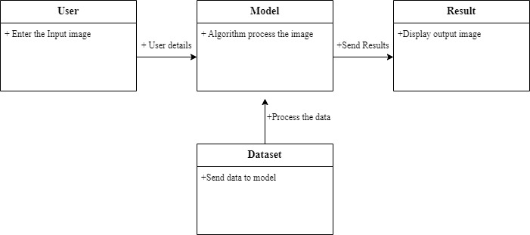

**Fig 4.1: Class diagram for Single Image Super Resolution using SRGAN Model**

**4.2.2 SEQUENCE DIAGRAM**

**Fig 4.2: Sequence diagram for Single Image Super Resolution using SRGAN Model**

This sequence diagram illustrates the flow of messages between objects involved in the process of generating a high-resolution image with SIFT analysis. It provides a visual representation of the interactions and the order in which they occur, helping to understand the sequence of events in the system.

**4.2.3** **USE CASE DIAGRAM**

The use case diagram offers a summarization and transparent illustration of the system's features and the actors engaged, facilitating comprehension of the system's conduct and necessities from a user's viewpoint.

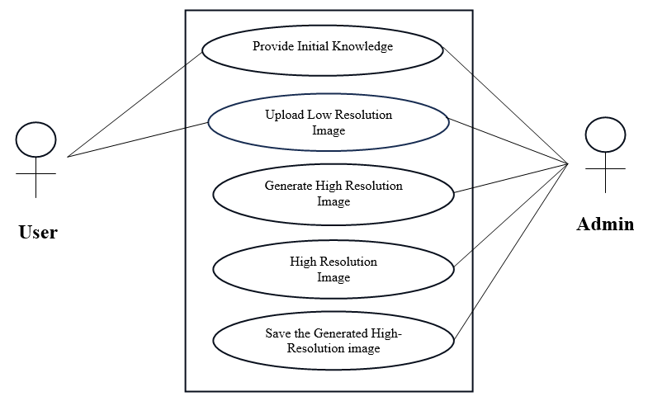

**Fig 4.3: Use Case Diagram for Single Image Super Resolution**

**4.2.4 DATA BASE DESIGN**

Database design involves arranging and structuring data in a database system to facilitate effective information retrieval, storage, and manipulation. For a high-resolution image generation system combined with SIFT analysis, we will focus on designing a database schema that can store the generated high-resolution images and their key points.

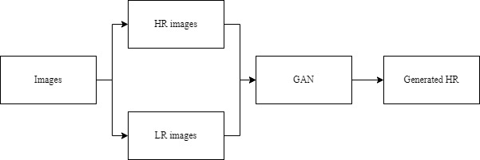

**Fig 4.4: Data Base Diagram for Single Image Super Resolution using SRGAN Model**

**4.2.5 CONTENT DIAGRAM OF PROJECT**

A content diagram, often referred as a content model or structure diagram, visually represents the organization and structure of content within a project or system. It offers a broad and detailed view of the various types of content, their interrelationships, and their arrangement within the project.

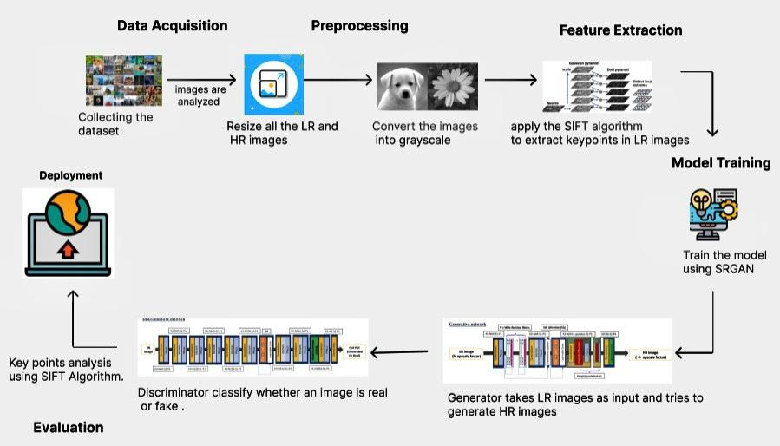

**Fig 4.5: Content diagram of Single Image Super Resolution using SRGAN Model**

**4.3 MODULE DESIGN AND ORGANISATION**

Module Design and Organization refers to the process of breaking down the system into smaller and more manageable modules or components, each responsible the specific functionality or tasks. This section typically outlines how the system's functionality is organized into different modules and how these modules interact with each other to achieve the system's objectives.

By organizing the system into modular components, each with well-defined responsibilities and interfaces, the development process can be streamlined, and the system's maintainability, scalability, and reusability can be enhanced. Additionally, clear module boundaries facilitate collaboration among team members and support incremental development and testing efforts.

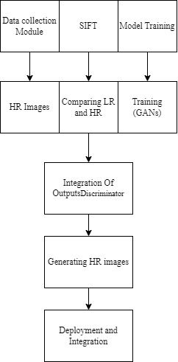

**Fig 4.6: Modular Design and Organization diagram for Single Image Super Resolution using SRGAN Model**

**4.4 SUMMARY**

The high-resolution image generation system combined with SIFT analysis represents a holistic solution aimed at automating the process of generating images while preserving key features and points extracted from them. The combination of computer vision and natural language processing techniques is the focus of this ambitious research to produce visually compelling images while bridging the semantic gap between input low-resolution images and the generated high-resolution counterparts.

At its core, the system leverages advanced computer vision algorithms to enhance the resolution of input images, ensuring that crucial details and features are preserved in the generated high-resolution images. This process involves the utilization of deep learning models, such as SRGANs (Super Resolution Generative Adversarial Networks), to upscale the resolution of images while maintaining their visual fidelity. Additionally, the system incorporates SIFT (Scale-Invariant Feature Transform) analysis to extract meaningful features and key points from both the low-resolution input images and the generated high-resolution images.

**CHAPTER-5**

**IMPLEMENTATION AND RESULTS**

**CHAPTER-5**

**IMPLEMENTATION AND RESULTS**

**5.1 INTRODUCTION**

With the integration of high-resolution imaging, numerous sectors such as photography, medical diagnostics, geographical mapping, and digital artistry are undergoing remarkable transformations. Among the advancements driving this change, machine learning stands out as a pivotal technology. The primary objective of this initiative is to elevate low-resolution images to high-resolution standards using ML algorithms. To ensure fidelity in preserving key features from the original low-resolution images, the project employs the Scale-Invariant Feature Transform algorithm, a cornerstone in the realm of image analysis.

The project's user-centric approach enables seamless navigation, search, and customization of images through an intuitive interface. Powering this interface is the SRGAN (Super-Resolution Generative Adversarial Network) ML model, meticulously trained to enhance image resolution. To democratize access to high-quality imaging, the implementation includes a web-based platform within the Single Image Super-Resolution (SISR) application. This platform empowers users to effortlessly upload their LR images and retrieve meticulously enhanced high-resolution counterparts.

The revolutionary outcomes of SISR, leveraging cutting-edge deep residual networks, promise to revolutionize image clarity and quality across diverse sectors. By enriching visual content and preserving intricate details, this application amplifies the aesthetic appeal and informational value of images. Consequently, users are poised to benefit from heightened image fidelity and fostering informed decision-making, professional photography to advanced medical diagnostics and beyond.

* 1. **IMPLEMENTATION OF KEY FUNCTIONS**

The proposed system comprises several vital modules, each integral to the system's functionality. Each module must be implemented in sequence to ensure the smooth operation of the application. Here is an overview of the major modules:

**Data Acquisition**: This module is responsible for retrieving images from the Image Super Resolution dataset. Libraries such as OpenCV and OS are utilized to read various image formats and provide paths to access the images.

**Data Preprocessing**: Once the data is acquired, it undergoes cleaning and preprocessing to eliminate discrepancies, duplicates, or errors. Activities such as missing value imputation, feature scaling, and data normalization are carried out to guarantee the consistency and quality of the data.

**Feature Extraction**: The Scale Invariant Feature Transform Algorithm is employed to extract key characteristics and points from the low-resolution images. This process helps identify important features within each image, providing crucial insights for subsequent processing.

**Model Selection**: The selection of the suitable machine learning model is made depending on

on the task at hand. In this case, the Super-Resolution Generative Adversarial Network (SRGAN) is chosen for its effectiveness in enhancing image resolution through adversarial training of generator and discriminator networks.

**Evaluation**: The performance of the trained SRGAN model is evaluated using quantitative metrics such as Peak Signal-to-Noise Ratio (PSNR) and Structural Similarity Index (SSIM). Additionally, a visual inspection of the generated high-resolution images is conducted to assess perceptual quality and detail enhancement.

**Feature Restoration and Key Point Matching**: The SIFT algorithm is again utilized to restore features in the generated HR images. Key points are identified, and matching is performed between LR and generated HR images to showcase feature restoration and preservation.

**Front End Application**: The final module involves deploying the top-performing ML model using Streamlit as a front-end application. This enables users to easily interact with the application by uploading their LR images and retrieving corresponding HR images as output. The user-friendly interface enhances accessibility and usability, allowing users to seamlessly engage with the system.

By meticulously implementing each of these modules, the system is poised to deliver enhanced image resolution and preservation of critical visual features, catering to a wide range of applications and user needs.

* 1. **METHOD OF IMPLEMENTATION**

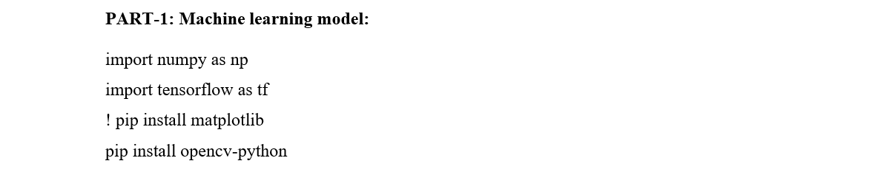

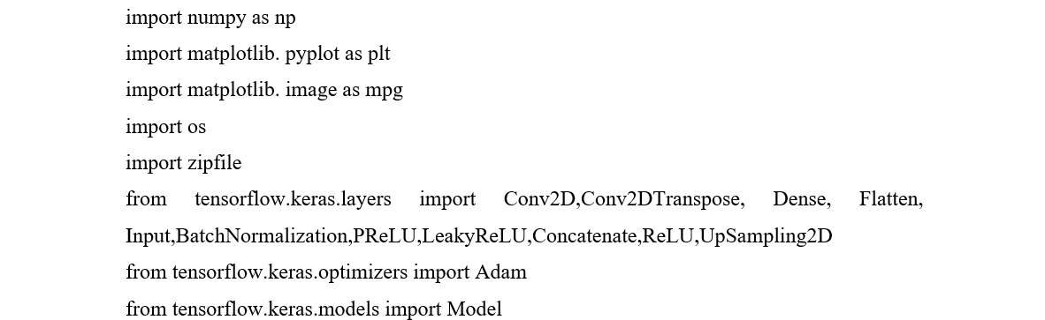

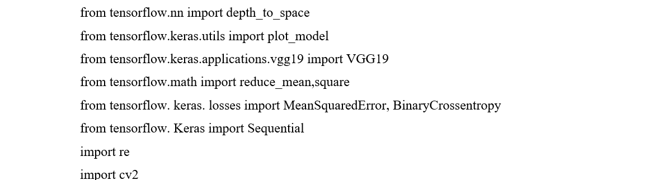

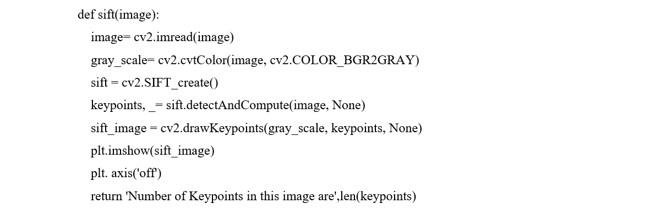

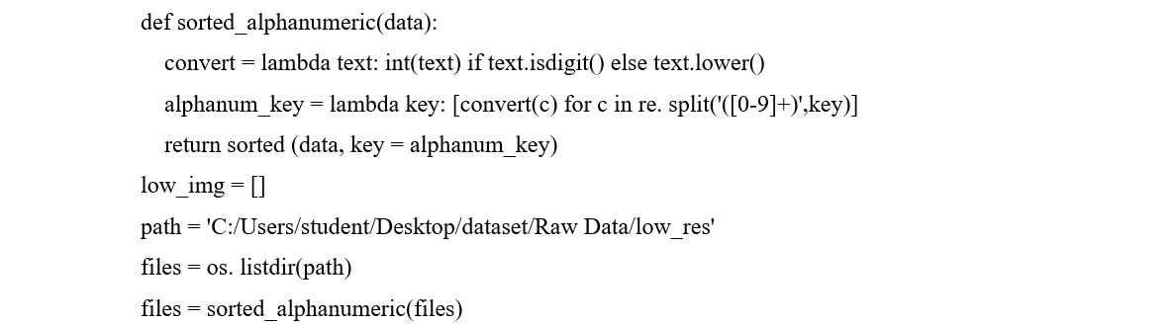

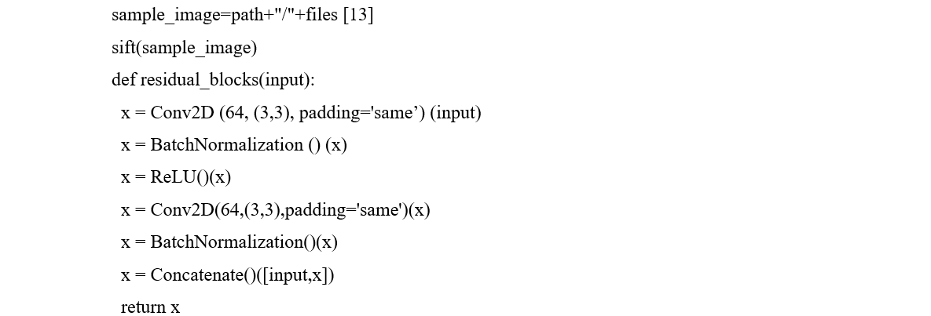

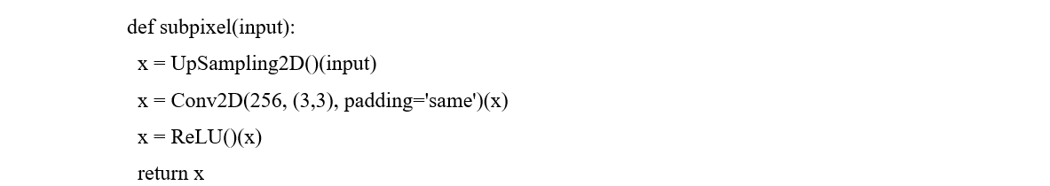

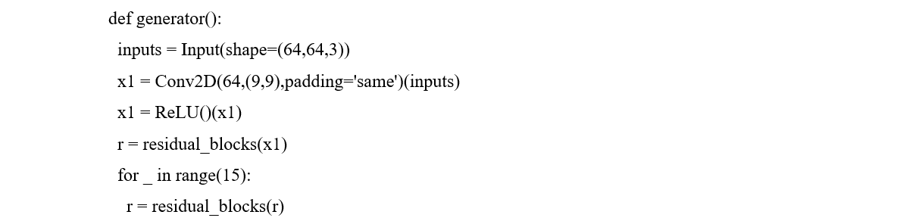

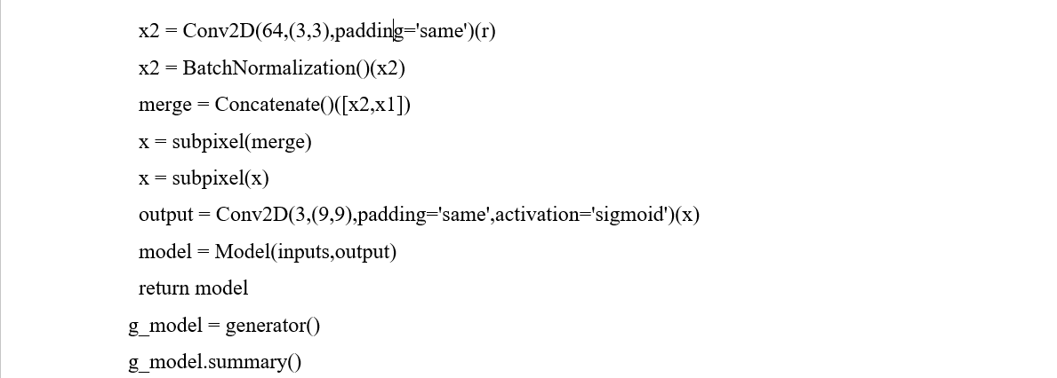

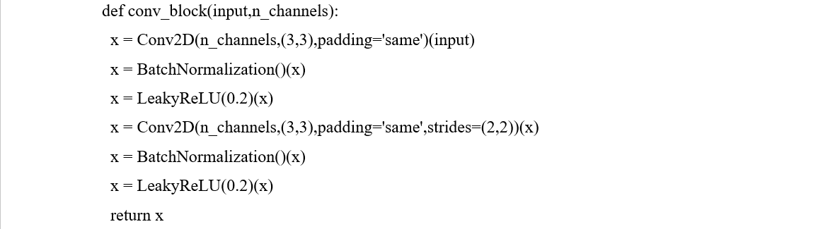

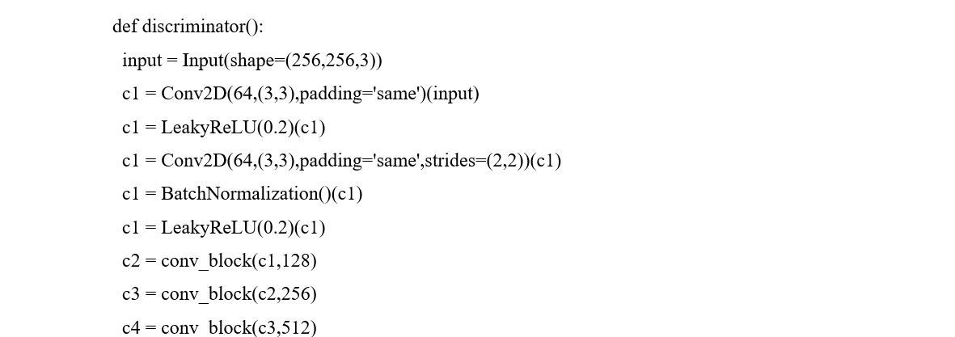

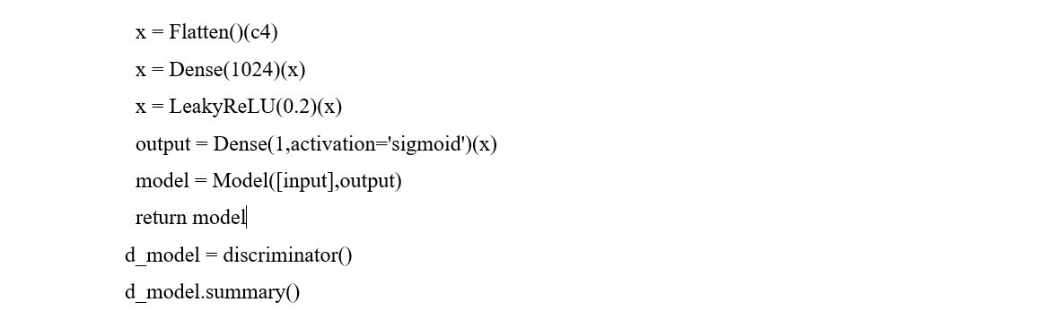

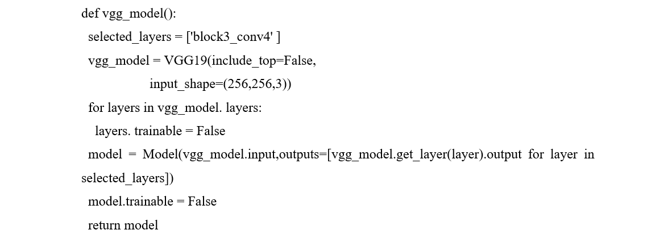

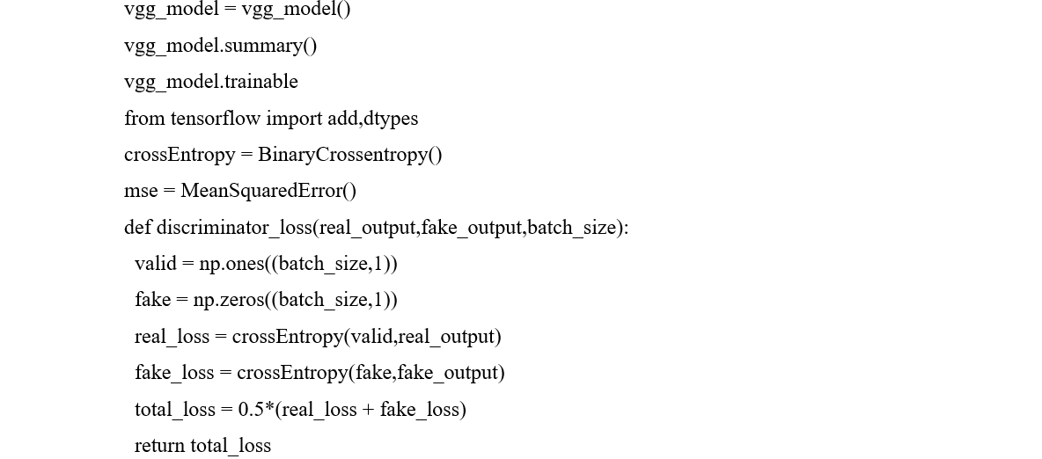

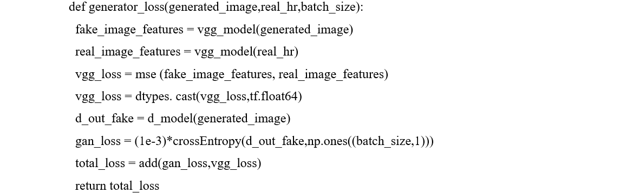

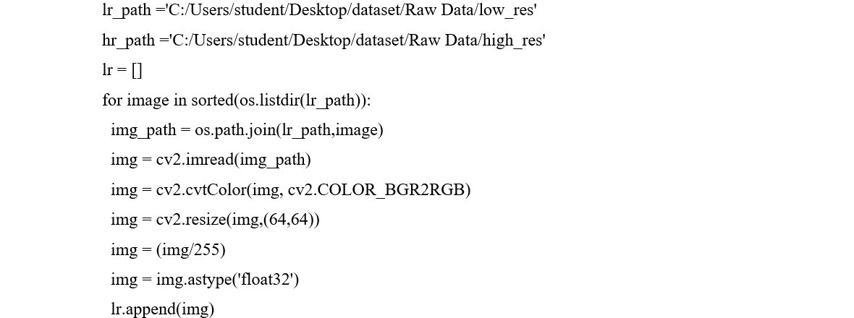

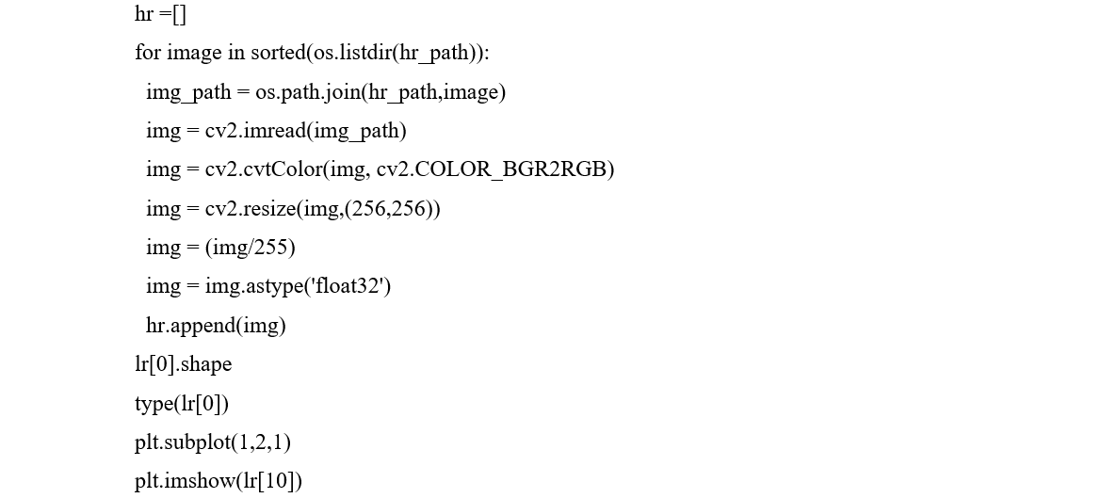

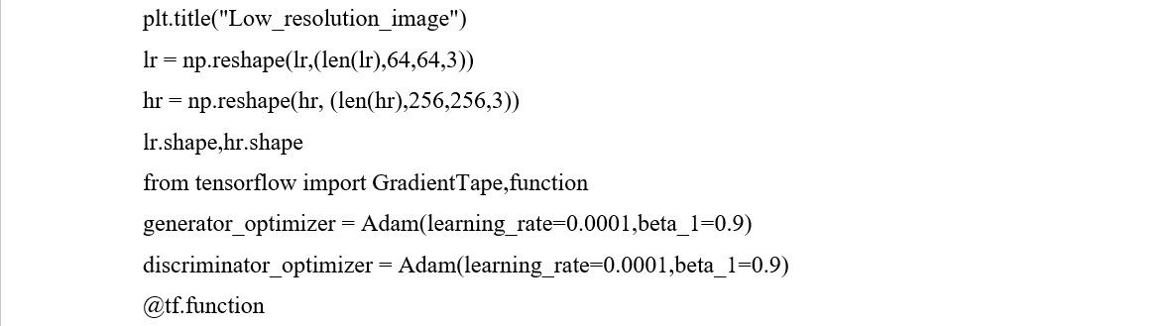

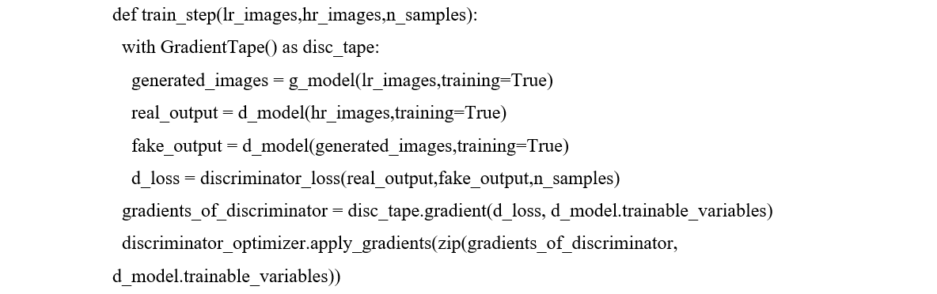

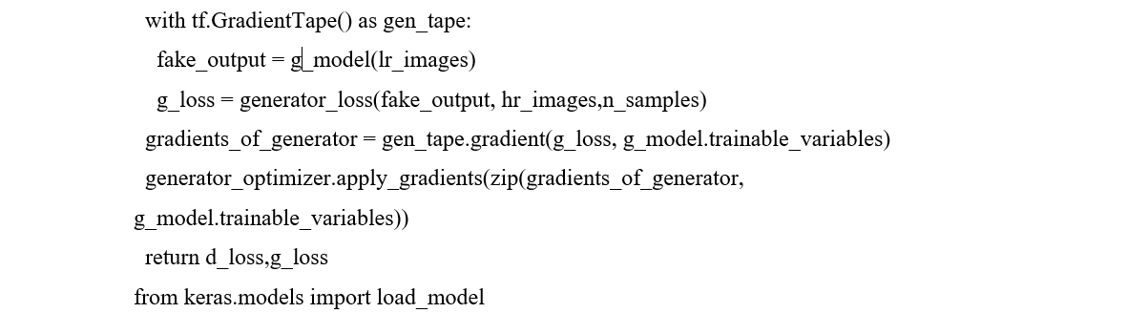

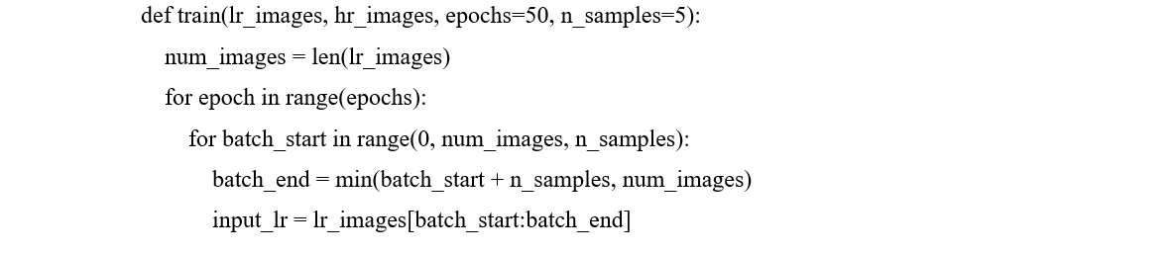

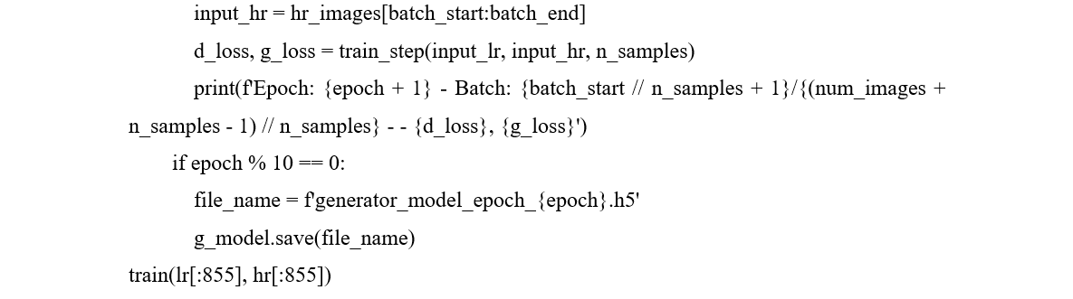

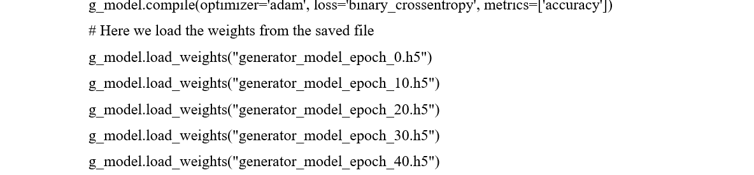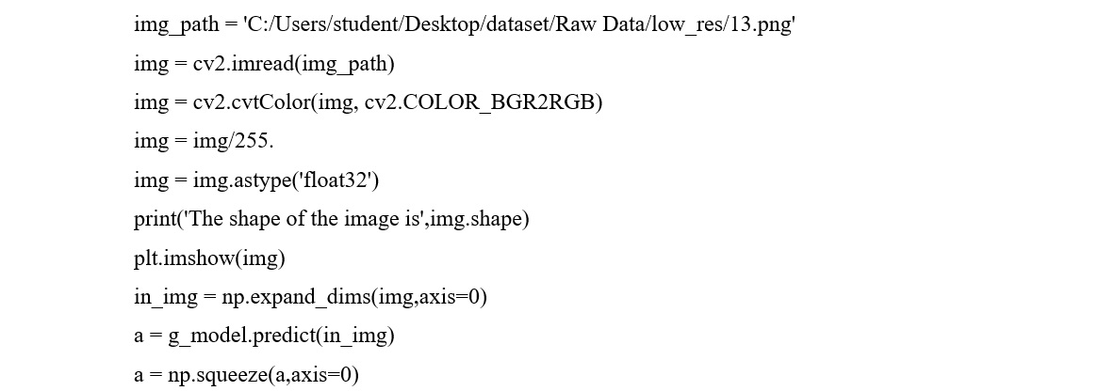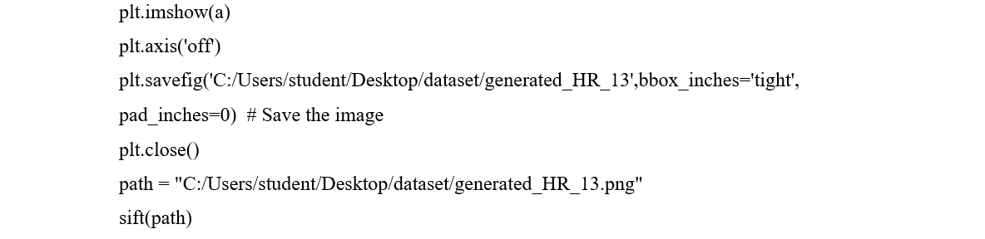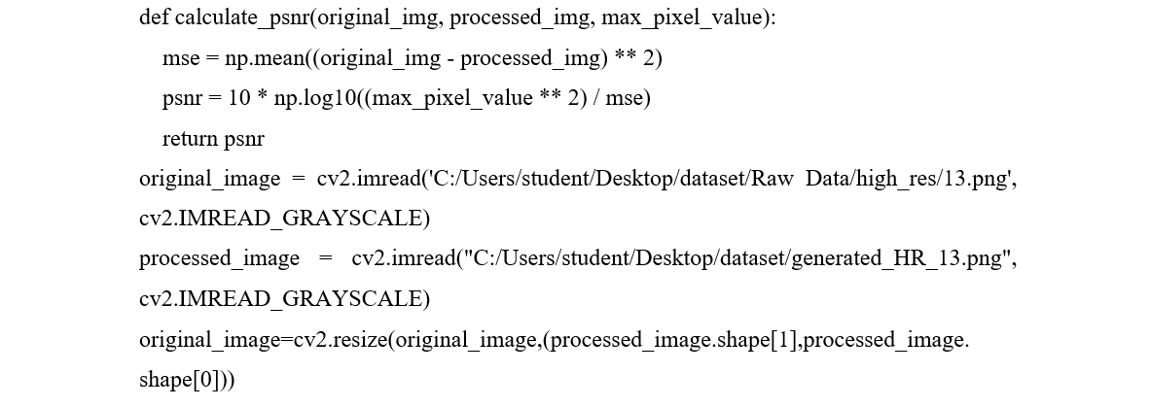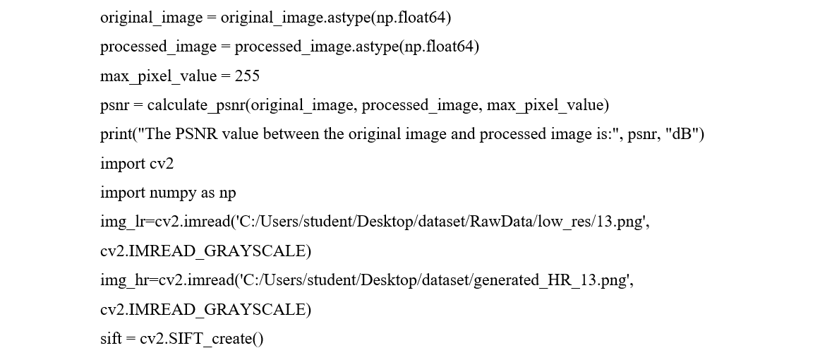 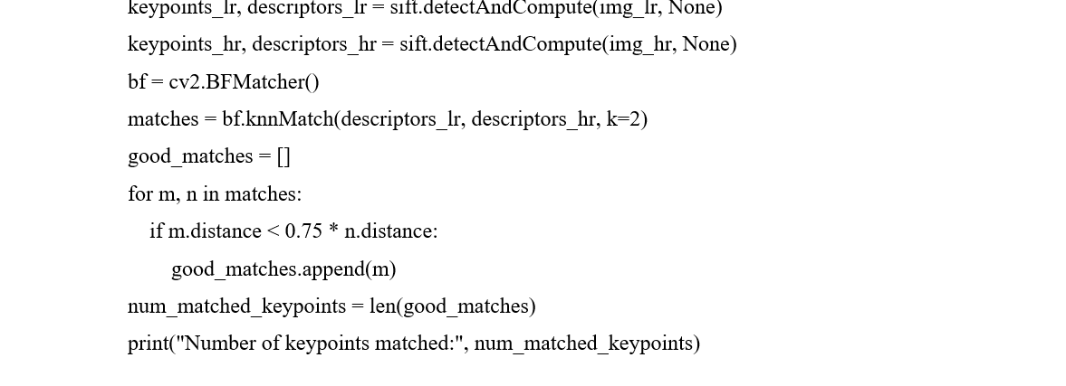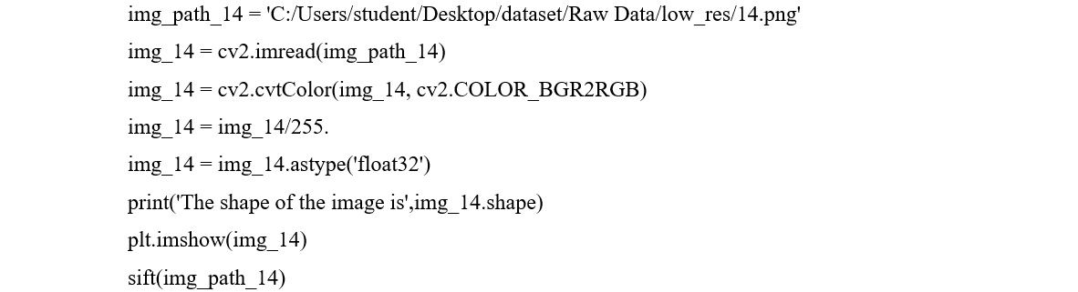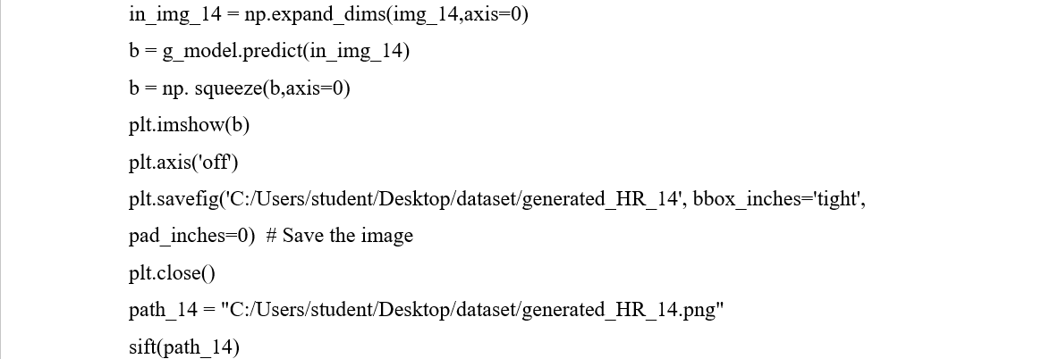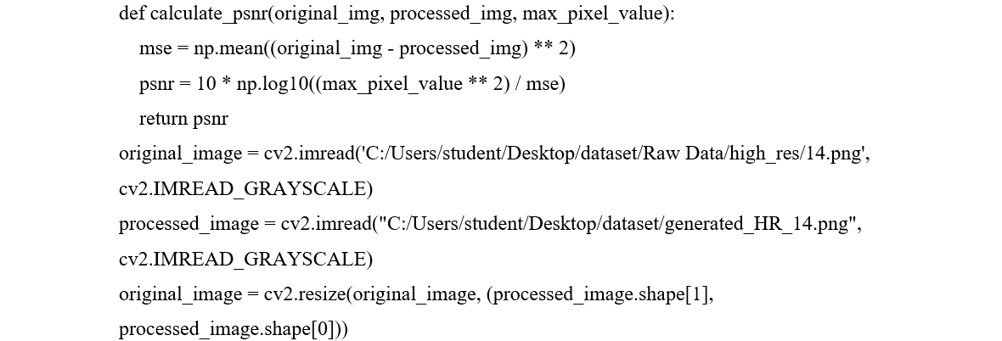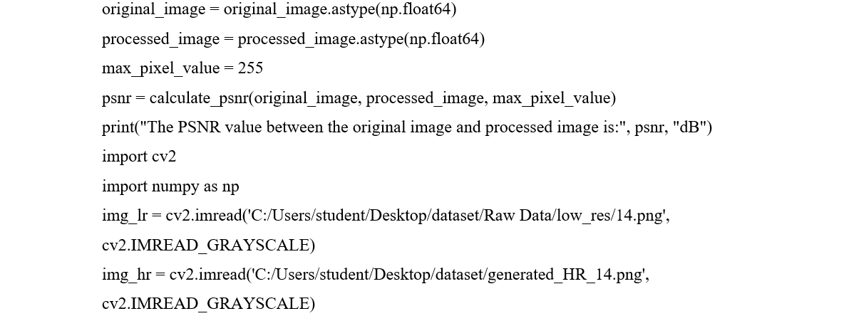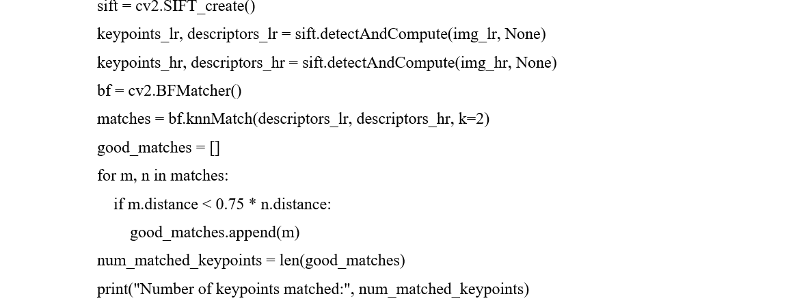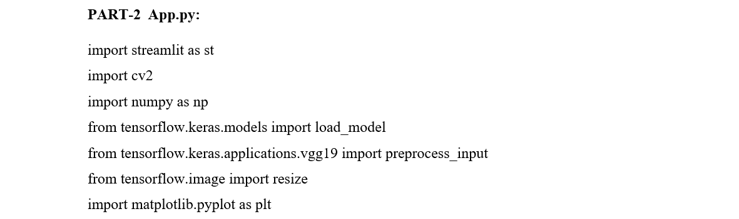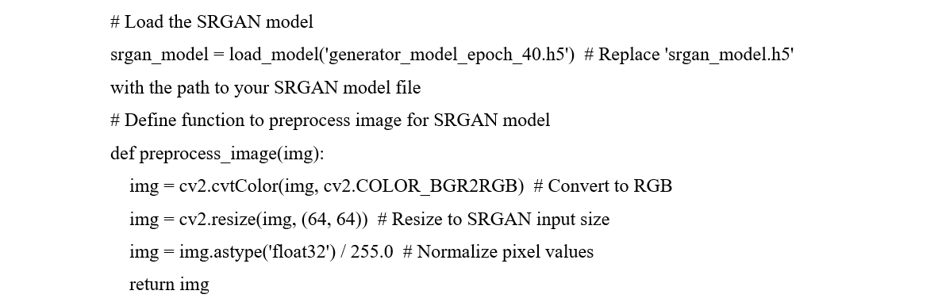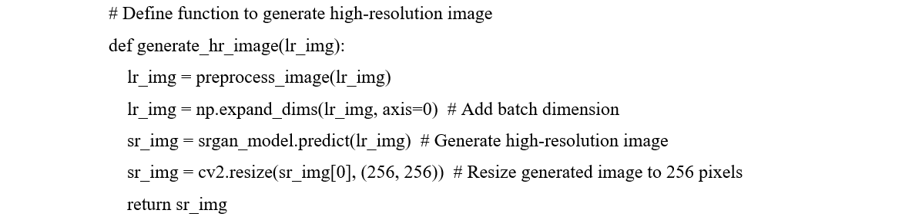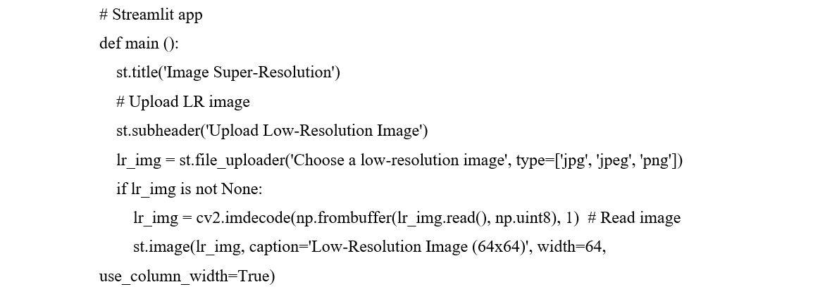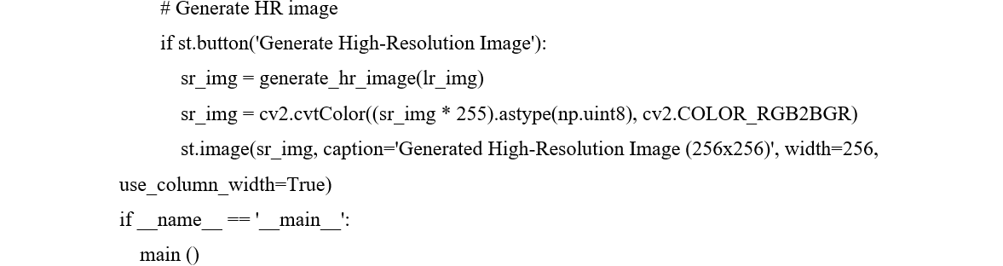

* 1. **OUTPUT SCREENS AND RESULT ANALYSIS**

With a clear and straightforward interface, the Image Super Resolution interface is made with user-friendliness in mind. Users can traverse the website with ease to get the upload images and get their required, high-resolution image.



**Fig 5.1: Home Page**

Upon visiting the Image Super Resolution interface, users are greeted with a clear and straightforward title: "Image Super Resolution." Below the title, users are prompted tchoose a low-resolution image. This interface is designed with user-friendliness in mind, ensuring that users can easily understand the purpose of the website and take the necessary action to enhance their images. The simplicity of the interface allows users to focus on the task at hand without any confusion.

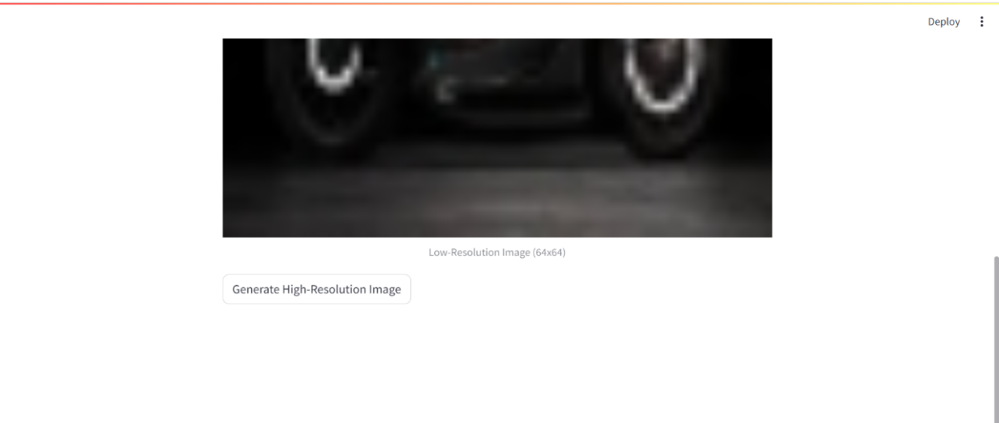

**Fig 5.2: Generate High-Resolution Image Page**

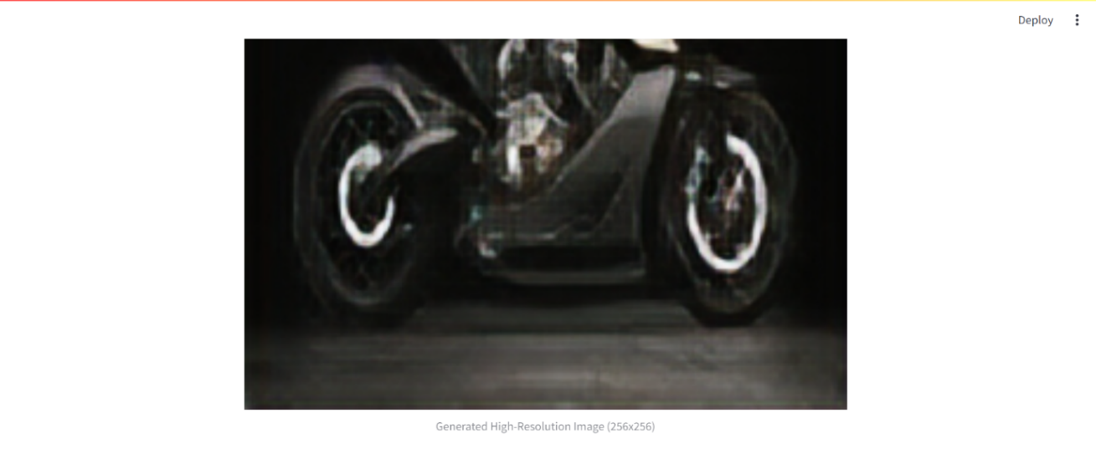After users have selected their low-resolution image, a button appears on the interface labeled "Generate High Resolution Image." This button serves as the next step in the process, guiding users toward the desired outcome of obtaining a high-resolution version of their chosen image. By presenting a single clear action for users to take, the interface maintains its user-friendly design, making it easy for users to progress to the next stage of the image enhancement process.

**Fig 5.3: Output Display Page**

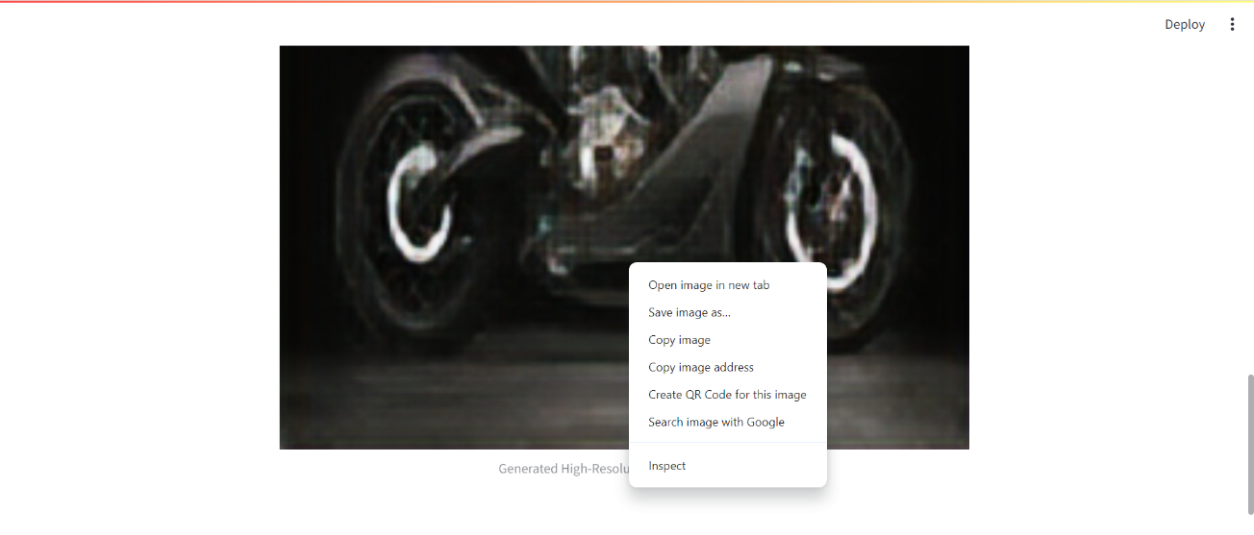Upon clicking the "Generate High Resolution Image" button, users are presented with the corresponding high-resolution image as the output. This stage completes the main objective of the Image Super Resolution interface, providing users with the enhanced image they were seeking. By delivering the desired result promptly and efficiently, the interface reinforces its user-friendly nature, ensuring that users can easily achieve their goals without encountering any obstacles.

**Fig 5.4: Save Page**

Once the high-resolution image is displayed, users have the option to interact with it further. By right-clicking on the image, users can access a menu containing various options, such as copying the image or saving it. This functionality allows users to easily manipulate and store the enhanced image according to their preferences. Whether they want to use the image for personal or professional purposes, the interface provides users with the flexibility to manage the output conveniently. This final stage of the process enhances the overall user experience, empowering users to make the most of their newly generated high-resolution image.

 

**Fig 5.5: Low Resolution and its corresponding High-Resolution Image**

After completing the process of generating both the low-resolution (LR) and high-resolution (HR) images, users are presented with the results displayed below. This clear and concise presentation ensures that users can easily locate and access their images without any confusion. By showcasing the LR and HR images together, users can compare the enhancements made and appreciate the improvements achieved through the image super-resolution process. This intuitive layout helps users navigate the interface seamlessly, allowing them to review and save their images with ease. Whether they need to download both versions for different purposes or simply admire the transformation, the interface empowers users to manage their images efficiently.

**Analysis Using SIFT Algorithm:**

SIFT is applied to both the input LR images and the generated HR images to detect key points, which represent distinctive features in the images. By comparing the number and distribution of key points between the LR and generated HR images, we can assess the preservation and enhancement of image details during the super-resolution process.

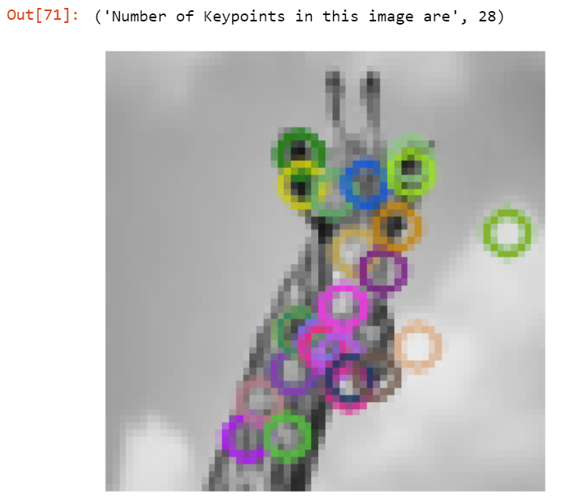

**Fig 5.6: Key points in Low Resolution Image**

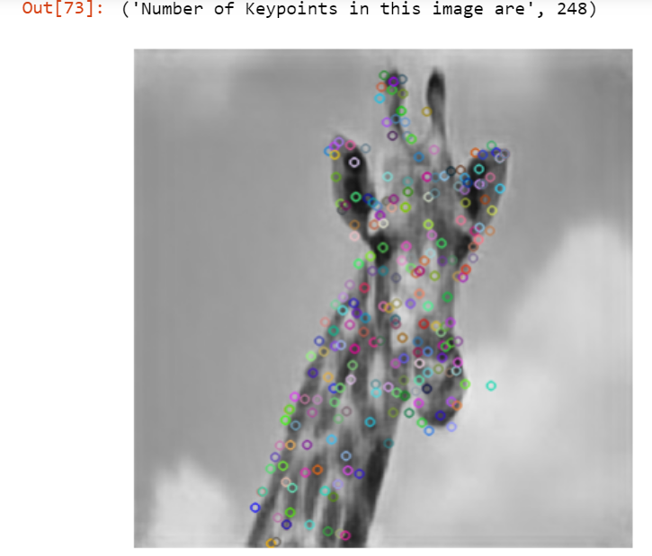

**Fig 5.7: Key points in its High-Resolution Image**

Furthermore, we conduct key point matching between the LR and generated HR images to quantify the restoration of key points. This analysis enables us to determine the extent to which the SRGAN model successfully restores important image features present in the LR images. By leveraging the SIFT algorithm for feature detection and matching, we gain insights into the fidelity and accuracy of the super-resolution process, providing valuable information for evaluating the performance of the SRGAN model and guiding further improvements.

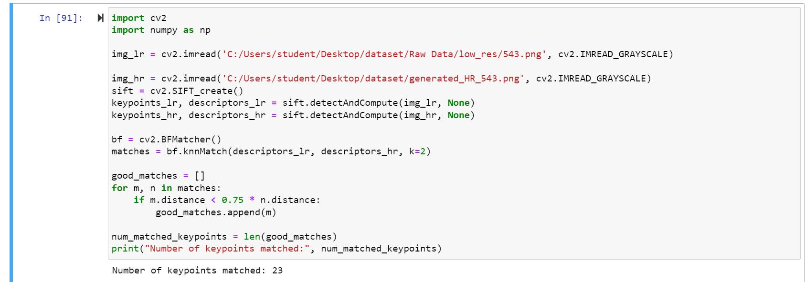

**Fig 5.8: Key points matched in both images**

* 1. **SUMMARY**

In conclusion, the deployment of Image Super Resolution marks a significant success in the realm of image enhancement technology. The project has effectively delivered a user-friendly platform that not only enhances images but also restores key points with precision. Leveraging cutting-edge algorithms and machine learning techniques, the implementation strategy has proven instrumental in producing accurate results while ensuring an enhanced user experience. Through clear output screens and comprehensive result analysis, the system showcases its capabilities, demonstrating its proficiency in transforming low-resolution images into high-resolution counterparts. This success underscores the importance and potential of single-image super-resolution as a valuable tool for image enhancement, promising a paradigm shift in how images are processed and improved.

The system's performance speaks volumes about its effectiveness in addressing the need for high-quality image enhancement. By seamlessly integrating advanced algorithms and machine learning methodologies, the project has paved the way for a streamlined approach to image enhancement. The clear display of the system's capabilities in the output screens and result analysis highlights its potential to revolutionize the way we perceive and manipulate images. With the ability to completely transform low-resolution images into high-resolution counterparts, the Image Super Resolution system offers a glimpse into the future of image processing technologies. As a versatile and powerful tool, it opens new avenues for creative expression and practical applications, further solidifying its position as a cornerstone in the field of image enhancement.

**CHAPTER-6**

**TESTING AND VALIDATION**

**CHAPTER-6**

**TESTING AND VALIDATION**

### 6.1 INTRODUCTION

**INTRODUCTION TO TESTING**

Testing is a procedure that makes the program's mistakes visible. It serves as the primary quality indicator used in the software development process. During testing, a series of test cases are used to execute the program, and the output for each test case is assessed to see if the program is functioning as it should or not. The many tiers of testing procedures are applied at various stages of software development to ensure that the system is error-free.

**UNIT TESTING**

Designing test cases for unit testing guarantees that program inputs produce valid outputs and that the fundamental logic of the program is operating as intended. Verifying every decision branch and the internal code flow is crucial. It is the independent software component testing for the application. Unit tests investigate a specific configuration of a system, application, or business process and perform basic tests at the component level.

**INTEGRATION TESTING**

Integration tests are performed on combined software components to verify that they function as a single application. Event-driven testing concentrates more on the core functionality of screens or fields. Integration tests show that the whole is correct and consistent, even when unit testing proved the individual components to be effective. The purpose of integration testing is to identify problems that arise when components are combined.

**SYSTEM TESTING**

Systems made up of both software and hardware are evaluated as an integrated whole to make sure they meet the established standards. System testing falls under black box testing and should not require knowledge of the underlying workings of the logic or code.

### DESIGN OF TEST CASES AND SCENARIOS

The modules under test, description, input, output, and remarks for Single Image Super Resolution is shown in the below table.

|  |  |
| --- | --- |
| Module Under Test | App.py |
| Description | User needs to select the desired low-resolution images in their system to get their desired high-resolution images. |
| Input | Upon visiting the Image Super Resolution interface, users are greeted with a clear and straightforward title: "Image Super Resolution." Below the title, users are prompted to choose a low-resolution image of their choice. |
| Output | Users upon clicking the "Generate High Resolution Image" button, users are presented with the corresponding high-resolution image as the output. |
| Remarks | Test Successful. |

**Table 6.1 Test Case for control**

**TEST CASE: 1**

Furthermore, we use the Structural Similarity Index (SSIM) and Peak Signal-to-Noise Ratio (PSNR) metrics to objectively evaluate the quality of the HR pictures that are created. PSNR provides a measure of the fidelity of the generated images compared to the ground truth HR images, while SSIM evaluates the perceptual similarity between the two images by considering their luminance, contrast, and structure. By computing these metrics, we can objectively evaluate the performance of the SRGAN model in generating high-quality HR images from LR inputs, providing insights into its effectiveness and accuracy.

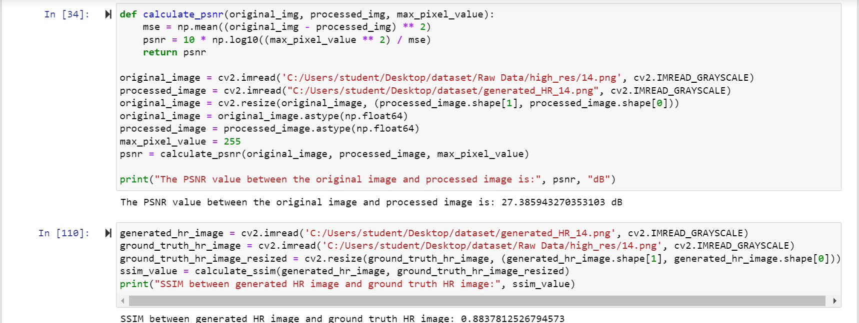

**Fig 6.1: PSNR and SSIM metrics**

### VALIDATION TESTING

An often-used statistic called PSNR (Peak Signal to Noise Ratio), which is frequently the image's peak pixel value. Equation 1 is used to assesses the quality of the reconstructed image by comparing the maximum possible strength of the signal to the power of the noise that compromises the reconstruction's accuracy. For PSNR, the value is represented in decibels (dB). Better fidelity is shown by a higher PSNR value, which suggests that the reconstructed image closely resembles the original high-resolution image. The three factors that the Structural Similarity Index (SSIM) considers when calculating the similarity between an original picture (x) and a reconstructed image (y) are luminance similarity, contrast similarity, and structural similarity. Equation 2 is used to show the perfect resemblance between the two photos which is indicated by a score of 1, and the SSIM index runs from -1 to 1. Greater picture similarity is indicated by a higher SSIM value.

*PSNR=10.log10(max(I)2/MSE)* Eq (1)

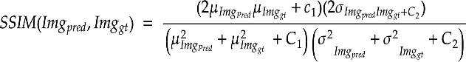 Eq (2)

where, picture’s highest potential pixel value is max(I) and MSE stands for Mean Squared Error, the predicted and ground truth HR images are Imgpred and Imggt with μ as the average mean, σ2 as the variance and c1 and c2 as the two variables to stabilize the division with weak denominator.

**Table 6.2: Validation of Results**

|  |  |
| --- | --- |
| **Metric** | **Average Value** |
| Peak Signal to Noise Ratio | 27.6 |
| Structural Similarity Index | 0.91 |

### 6.4 SUMMARY

Testing and validation play pivotal roles in the success of projects involving machine learning algorithms, as highlighted in the context of Single Image Super Resolution. Through the meticulous creation of test cases and scenarios, the efficacy and performance metrics of ML models used in the project were rigorously assessed. This process ensured that the models operated as intended and could effectively address various scenarios and edge cases. By subjecting the ML algorithms to thorough validation, the project team gained confidence in their functionality and ability to deliver reliable results. Consequently, the quality and dependability of the SISR system were significantly enhanced, demonstrating the indispensable role of testing and validation in bolstering the performance of ML-driven projects.

The success of the Single Image Super Resolution project underscores the critical importance of prioritizing testing and validation in ML endeavors. The comprehensive testing procedures implemented not only affirmed the functionality of the ML models but also contributed significantly to the overall success of the project. By meticulously validating the algorithms, potential issues and limitations were identified and addressed, ensuring robust performance across diverse scenarios. As such, the emphasis on testing and validation emerged as a cornerstone of the project's success, underscoring the imperative nature of these processes in every ML project.

**CHAPTER-7**

**CONCLUSION**

**CHAPTER-7**

**CONCLUSION**

### 7.1 CONCLUSION

The integration of Single Image Super Resolution (SISR) using Machine Learning (ML) represents a promising avenue for enhancing image quality and clarity. By leveraging ML algorithms, the project aimed to overcome the limitations associated with low-quality images, preserving essential details, and enhancing overall visual fidelity. The envisioned system not only addresses existing challenges but also prioritizes user-friendliness, simplicity, and efficiency, ensuring widespread accessibility and usability.

Throughout the project lifecycle, meticulous attention was devoted to analysis, design, and execution phases. Software requirements were carefully identified, and comprehensive content and ER/UML diagrams were developed to guide system development. During the execution phase, critical system components were meticulously designed, integrated, and rigorously tested to ensure seamless functionality and reliability. This iterative process of design, integration, and testing laid the groundwork for a robust and dependable SISR system. Central to the project's success was the rigorous testing and validation process undertaken to guarantee system correctness and dependability. Through systematic validation efforts, the SISR system was meticulously assessed to ensure adherence to design specifications and operational efficiency. The creation of comprehensive test cases and scenarios facilitated thorough evaluation, ultimately enhancing the quality and dependability of the SISR solution. As a result, the project's commitment to testing and validation emerged as a cornerstone of its success, underscoring the pivotal role of these processes in ensuring the efficacy and reliability of ML-driven initiatives.

Overall, the Single image super resolution has shown that it can deliver remarkable improvements in image quality and clarity, demonstrating the transformative potential of ML-driven enhancement techniques. However, it is crucial to recognize the project's shortcomings, which include the need for further refinement in handling complex image scenarios and mitigating potential artifacts introduced during the upscaling process. Despite these challenges, ML technology has showcased its capability to effectively address image quality issues, as evidenced by the Single image super resolution utilizing ML project. The thorough analysis, design, testing, and validation procedures employed throughout the project were pivotal in its success, ensuring that the developed system met performance standards and delivered tangible enhancements. The project's findings underscore the potential of Single image super resolution employing ML as a promising avenue for enhancing images, offering a glimpse into the transformative power of ML in overcoming image quality limitations. Continued research and development in this area hold the promise of further refining and optimizing ML-driven image enhancement techniques, paving the way for even more significant advancements in visual processing and content generation.

### 7.2 FUTURE ENHANCEMANTS

* More interactive user interface.
* Explore techniques for fusing information from multiple sources, such as different imaging modalities or sensor data, to enhance image quality and robustness.
* Optimize algorithms and models for energy efficiency, enabling deployment on resource-constrained devices such as mobile phones or IoT devices without compromising performance.
* Developing mobile app and integrating it with web application

## **REFERENCES**

1. P. Ganesan and Murugesan, “Comparative Study of Implementation of Very Deep Super Resolution Neural Network and Bicubic Interpolation for Single Image Super Resolution Quality Enhancement,” IEEE International Conference on Applied Electromagnetics, Signal Processing &Communication (AESPC), Nov 2023
2. Gunnam Suryanarayana, Bhavana, and Md Zia Ur Rahman, “Deep Learned Singular Residual Network for Super Resolution Reconstruction,” Computers, Materials & Continua 2023 Article
3. Archana Tomar and Harish Patidar, “Enhancing image super-resolution with deep convolutional neural networks,” in ICTACT Journal on Image and Video Processing, vol.14, Nov 2023
4. B. Sai Bhavani, B. Gandhi Prakash, and B. Satish Kumar, “Image Super-Resolution Via a Convolutional Neural Network,” Indian Scientific Journal of Research in Engineering and Management, Vol. 07, Mar 2023
5. Sneha R Mhatre, Dr. Jagdish W. Bakal, “A Review of Image Super Resolution using Deep Learning,” International Journal on Recent and Innovation Trends in Computing and Communication, vol. 11, Apr 2023.
6. P.S. Hrishikesh, Densen Puthuserry and K.A. Akhil, “Relativistic GAN using Receptive Field Block for Single Image Super-Resolution with improved Perceptual Quality**,” 2023 11th International Symposium on Electronic Systems Devices and Computing (ESDC), May 2023**
7. Eunseo Lee and Taek Geun Whang-Bo, “Performance Comparison of Enhanced Deep Residual Networks for Single-image Super Resolution Model with Change in Loss Function,” **Joint International Conference on Digital Arts, Media, and Technology with ECTI Northern Section Conference on Electrical, Electronics, Computer and Telecommunications Engineering, Mar 2023**
8. Hongjie Cao, “Studies Advanced in Image Super-resolution Reconstruction based on Deep Learning,” Conference on Computer, Machine Learning and Artificial Intelligence (CMLAI) 2023, vol. 11
9. Karansingh Chauhan, Shail Nimish Patel and Malaram Kumhar, “Deep Learning-Based Single-Image Super-Resolution: A Comprehensive Review,” in Mar 2023 IEEE Access Volume 11
10. Zhonghao Wu and Hengyang Wu, “Improved SIFT image feature matching algorithm,” 2022 2nd International Conference on Computer Graphics, Image, and Virtualization (ICCGIV), Sep 2022
11. N. Sasikala, V. Swathi Priya, M. Ashwini, V. Preethi, A. Pranavi, and M. Ranjith, “Feature Extraction of Real-Time Image Using SIFT Algorithm,” European Journal of Electrical Engineering and Computer Science, vol. 4, No. 3, May 2020
12. Sivaram Prasad Mudunuri, Soubhik Sanyal, and Soma Biswas, “Genlr-net: Deep framework for very low-resolution face and object recognition with generalization to unseen categories,” in The IEEE Conference on Computer Vision and Pattern Recognition (CVPR) Workshops, June 2018
13. B. Lim, S. Son, H. Kim, S. Nah, and K. M. Lee, “Enhanced deep residual networks for single image super-resolution,” in 2017 IEEE Conference on Computer Vision and Pattern Recognition Workshops (CVPRW), July 2017.
14. J. Kim, J. K. Lee, and K. M. Lee, “Accurate image super resolution using very deep convolutional networks,” in 2016 IEEE Conference on Computer Vision and Pattern Recognition (CVPR), June 2016.
15. Z. Wang, S. Chang, Y. Yang, D. Liu, and T. S. Huang, “Studying very low-resolution recognition using deep networks,” in 2016 IEEE Conference on Computer Vision and Pattern Recognition (CVPR), June 2016.
16. C. Dong, C. C. Loy, K. He, and X. Tang, “Image super resolution using deep convolutional networks,” IEEE Transactions on Pattern Analysis and Machine Intelligence, vol. 38, no. 2, Feb 2016.